CloneZilla Computer Imaging Guide

CloneZilla Bootable USB Thumbdrive Setup Guide:
1. Download clonezilla live from the link on:
https://clonezilla.org/downloads/download.php?branch=stable

- CPU Architecture should be AMD64
- File type should be zip
- Hit download

2. Make sure your USB flash drive is formatted as FAT32. (I believe) you need a 32gb or less USB thumbdrive for this to be possible. Google “How to format usb drive fat32” if you have any questions. You will be able to do it from within Windows, without downloading any additional software.

3. Extract ALL of the contents of the zip file to your USB drive. Structure is important. When you get done, it should look like this:
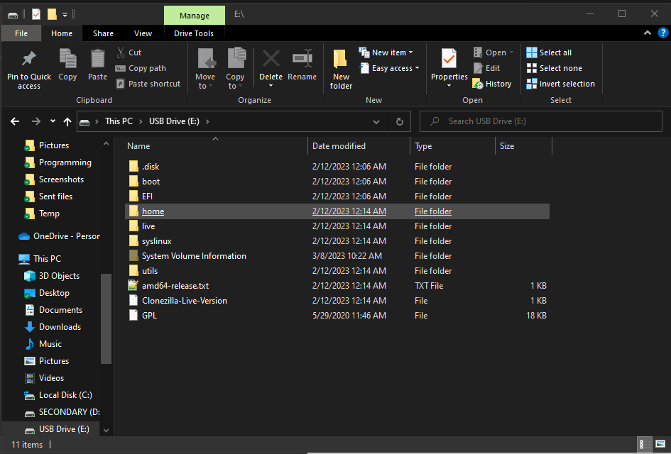
4. Go into the \utils\win64\ folder on your thumbdrive, and right click makeboot64.bat and choose “Run As Administrator”

5. Read the information on the screen and press enter.

You should finish with this window with no errors:

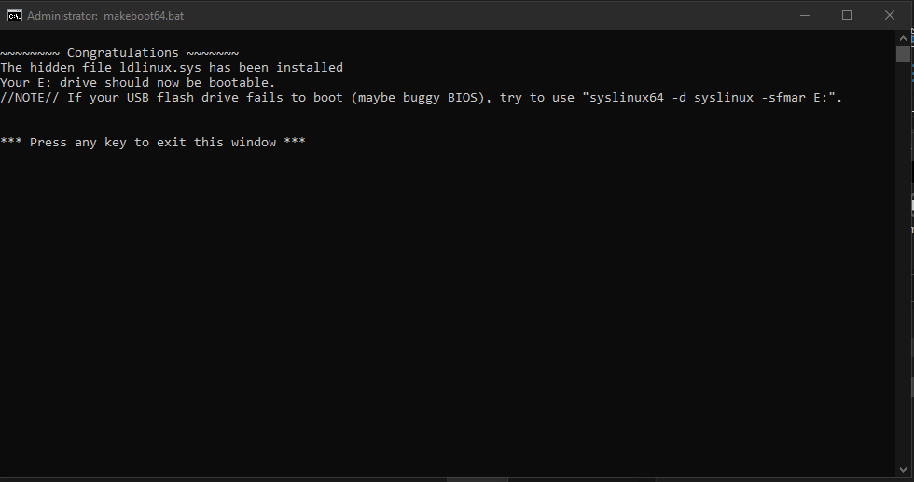
(Obviously your thumbdrive letter may not be E:\ like mine is. Everything else should look the same, though.)

6. Eject the USB Thumbdrive and wait for the “Device can be safely removed message” before removing the thumbdrive from your computer.

